**Міністерство освіти і науки України**

**Національний технічний університет України «Київський політехнічний інститут імені Ігоря Сікорського"**

**Факультет інформатики та обчислювальної техніки**

**Кафедра інформатики та програмної інженерії**

**Звіт**

з лабораторної роботи №2 з дисципліни

«Програмування інтелектуальних інформаційних систем»

„Метрики кластеризації/класифікації”

**Виконав(ла)**

(шифр, прізвище, ім'я, по батькові)

*ІП-11 Головня Олександр Ростиславович*

**Перевірив**

(прізвище, ім'я, по батькові)

*Баришич Л. М.*

Київ 2023

**Завдання 1**import pandas as pd

import matplotlib.pyplot as plt

import seaborn as sns

import numpy as np

from scipy.stats import norm

from sklearn.preprocessing import StandardScaler

from scipy import stats

data = '1.csv'

df = pd.read_csv(data, header=None, sep=', ', engine='python')

col_names = ['age', 'workclass', 'fnlwgt', 'education', 'education_num', 'marital_status', 'occupation', 'relationship',

             'race', 'sex', 'capital_gain', 'capital_loss', 'hours_per_week', 'native_country', 'income']

df.columns = col_names

df.head(5)

X = df.drop(['income'], axis=1)

y = df['income']

from sklearn.model_selection import train_test_split

X_train, X_test, y_train, y_test = train_test_split(X, y, test_size = 0.3, random_state = 0)

for df2 in [X_train, X_test]:

    df2['workclass'].fillna(X_train['workclass'].mode()[0], inplace=True)

    df2['occupation'].fillna(X_train['occupation'].mode()[0], inplace=True)

    df2['native_country'].fillna(X_train['native_country'].mode()[0], inplace=True)

import category_encoders as ce

encoder = ce.OneHotEncoder(cols=['workclass', 'education', 'marital_status', 'occupation', 'relationship',

                                 'race', 'sex', 'native_country'])

X_train = encoder.fit_transform(X_train)

X_test = encoder.transform(X_test)

from sklearn.naive_bayes import GaussianNB

from sklearn.svm import SVC

# Gaussian Naive Bayes

gnb = GaussianNB()

gnb.fit(X_train, y_train)

y_pred_gnb = gnb.predict(X_test)

# Support Vector Machine

svm = SVC()

svm.fit(X_train, y_train)

y_pred_svm = svm.predict(X_test)

from sklearn.metrics import recall_score

recall_gnb = recall_score(y_test, y_pred_gnb, pos_label='>50K')

recall_svm = recall_score(y_test, y_pred_svm, pos_label='>50K')

print('Gaussian Naive Bayes Recall:', recall_gnb)

print('Support Vector Machine Recall:', recall_svm)from sklearn.metrics import f1_score

f1_gnb = f1_score(y_test, y_pred_gnb, pos_label='>50K')

f1_svm = f1_score(y_test, y_pred_svm, pos_label='>50K')

print('Gaussian Naive Bayes f1-score:', f1_gnb)

print('Support Vector Machine f1-score:', f1_svm)

from sklearn.metrics import confusion_matrix

cm_gnb = confusion_matrix(y_test, y_pred_gnb)

cm_svm = confusion_matrix(y_test, y_pred_svm)

cm_matrix_gnb = pd.DataFrame(data=cm_gnb, columns=['Actual Positive:1', 'Actual Negative:0'],

                                 index=['Predict Positive:1', 'Predict Negative:0'])

cm_matrix_svm = pd.DataFrame(data=cm_svm, columns=['Actual Positive:1', 'Actual Negative:0'],

                                 index=['Predict Positive:1', 'Predict Negative:0'])

plt.figure(figsize=(10, 4))

plt.subplot(1, 2, 1)

sns.heatmap(cm_matrix_gnb, annot=True, fmt='d', cmap='YlGnBu')

plt.title('Confusion Matrix - GNB')

plt.subplot(1, 2, 2)

plt.title('Confusion Matrix - SVM')

sns.heatmap(cm_matrix_svm, annot=True, fmt='d', cmap='YlGnBu')

plt.show()

from sklearn.metrics import accuracy_score

print(f'Gaussian Naive Bayes accuracy score: {(accuracy_score(y_test, y_pred_gnb))}')

print(f'Support Vector Machine accuracy score: {(accuracy_score(y_test, y_pred_svm))}')

null_accuracy = (7407/(7407+2362))

print(f'Null accuracy score: {null_accuracy}')

print(f'Training set score: {gnb.score(X_train, y_train)}')

print(f'Test set score: {gnb.score(X_test, y_test)}')

print(f'Training set score: {svm.score(X_train, y_train)}')

print(f'Test set score: {svm.score(X_test, y_test)}')

**Recall metric**



(У SVM Recall набагато нижчий, а це значить, що SVM позначає багато істинних значень як хибні)

**F1 metric**

  
(У SVM нижчий – тому модель є менш збалансованою щодо точності та повноти)

**Matrix**

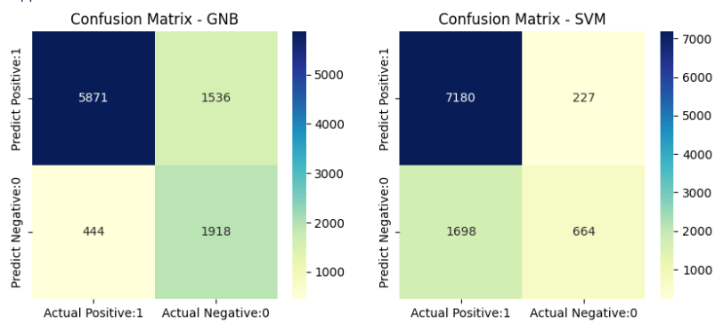

(GNM краще вгадує негативні, а SVM позитивні.)

**Accuracy score**



**null гіпотеза  
**

(Точність обох вище за нуль гіпотезу)

**Over/Under fitting for SVM**



**ЗАВДАННЯ 2**

import itertools

import numpy as np

import matplotlib.pyplot as plt

from matplotlib.ticker import NullFormatter

import pandas as pd

import matplotlib.ticker as ticker

from sklearn import preprocessing

df = pd.read_csv('2.csv')

df.head()

X = df[['region', 'tenure', 'age', 'marital', 'address', 'income', 'ed',

       'employ', 'retire', 'gender', 'reside']].values

X[0:5]

y = df['custcat'].values

y[0:5]

X = preprocessing.StandardScaler().fit(X).transform(X.astype(float))

X[0:5]

from sklearn.model_selection import train_test_split

X_train, X_test, y_train, y_test = train_test_split( X, y, test_size=0.25, random_state=4)

print ('Train set:', X_train.shape,  y_train.shape)

print ('Test set:', X_test.shape,  y_test.shape)

from sklearn.neighbors import KNeighborsClassifier

k = 4

#Train Model

euclidean = KNeighborsClassifier(n_neighbors = k, metric='euclidean').fit(X_train,y_train)

#Train Model

manhattan = KNeighborsClassifier(n_neighbors = k, metric='manhattan').fit(X_train,y_train)

#Train Model

minkowski = KNeighborsClassifier(n_neighbors = k, metric='minkowski').fit(X_train,y_train)

yhat_euclidean = euclidean.predict(X_test)

yhat_manhattan = manhattan.predict(X_test)

yhat_minkowski = minkowski.predict(X_test)

yhat_euclidean[0:10], yhat_manhattan[0:10], yhat_minkowski[0:10]

from sklearn.metrics import recall_score

# Calculate and compare recall scores

recall_euclidean = recall_score(y_test, yhat_euclidean, average='weighted')

recall_manhattan = recall_score(y_test, yhat_manhattan, average='weighted')

recall_minkowski = recall_score(y_test, yhat_minkowski, average='weighted')

print('Euclodean metric Recall:', recall_euclidean)

print('Manhattan metric Recall:', recall_manhattan)

print('Minkowski metric Recall:', recall_minkowski)

from sklearn.metrics import f1_score

f1_euclidean = f1_score(y_test, yhat_euclidean, average='weighted')

f1_manhattan = f1_score(y_test, yhat_manhattan, average='weighted')

f1_minkowski = f1_score(y_test, yhat_minkowski, average='weighted')

print('Euclodean metric f1-score:', f1_euclidean)

print('Manhattan metric f1-score:', f1_manhattan)

print('Minkowski metric f1-score:', f1_minkowski)

from sklearn.metrics import confusion_matrix

import seaborn as sns

cm_euclidean = confusion_matrix(y_test, yhat_euclidean)

cm_manhattan = confusion_matrix(y_test, yhat_manhattan)

cm_minkowski = confusion_matrix(y_test, yhat_minkowski)

plt.figure(figsize=(9, 3))

plt.subplot(1, 3, 1)

sns.heatmap(cm_euclidean, annot=True, fmt='d', cmap='Reds', cbar=False)

plt.title('Euclidean metric')

plt.xlabel('Predicted')

plt.ylabel('True')

plt.subplot(1, 3, 2)

sns.heatmap(cm_manhattan, annot=True, fmt='d', cmap='Purples', cbar=False)

plt.title('Manhattan metric')

plt.xlabel('Predicted')

plt.ylabel('True')

plt.subplot(1, 3, 3)

sns.heatmap(cm_minkowski, annot=True, fmt='d', cmap='Blues', cbar=False)

plt.title('Minkowski metric')

plt.xlabel('Predicted')

plt.ylabel('True')

plt.tight_layout()

plt.show()

from sklearn import metrics

print("Test set Accuracy for Euclodean metric: ", metrics.accuracy_score(y_test, yhat_euclidean))

print("Test set Accuracy for Manhattan metric: ", metrics.accuracy_score(y_test, yhat_manhattan))

print("Test set Accuracy for Minkowski metric: ", metrics.accuracy_score(y_test, yhat_minkowski))

pd.Series(y_test).value_counts()

null_accuracy = (70/(70+65+64+51))

print(f'Null accuracy score: {null_accuracy}')

print(f'Training set score: {euclidean.score(X_train, y_train)}')

print(f'Test set score: {euclidean.score(X_test, y_test)}')

print(f'Training set score: {manhattan.score(X_train, y_train)}')

print(f'Test set score: {manhattan.score(X_test, y_test)}')

print(f'Training set score: {minkowski.score(X_train, y_train)}')

print(f'Test set score: {minkowski.score(X_test, y_test)}')

**Recall metric**

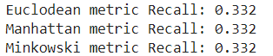

(Усі три мають низький)

**F1 metric**

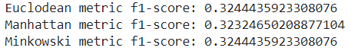  
(Ф1 досить низький – невисока точність та повнота)

**Matrix**

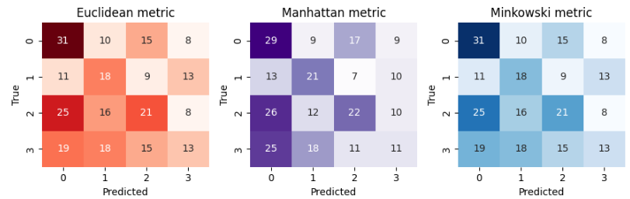

(Моделі часто помиляються.)

**Accuracy score**

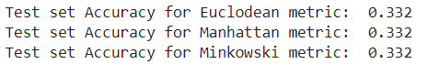

(Низька точність)  
**null гіпотеза  
**

(Точність усіх вище за нуль гіпотезу)

**Over/Under fitting for SVM**

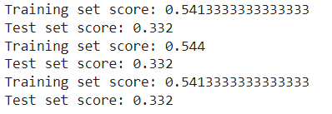

(Бачимо, що у всіх є Under fitting)

**ЗАВДАННЯ 3**

import numpy as np # linear algebra

import pandas as pd # data processing, CSV file I/O (e.g. pd.read_csv)

import matplotlib.pyplot as plt #Data Visualization

import seaborn as sns  #Python library for Vidualization

import os

np.random.seed(10)

from sklearn import cluster, datasets, mixture

X1,Y1 = datasets.make_moons(n_samples=2000, noise=.09,random_state=10)

plt.scatter(X1[:, 0], X1[:, 1], s=10, c=Y1)

plt.title('DATASET 1')

plt.xlabel('X axis')

plt.ylabel('Y axis')

plt.show()

from sklearn.datasets import make_blobs

X3,Y3  = make_blobs(n_samples=2000,cluster_std=3.5,centers=2, n_features=2,random_state=10)

plt.title('DATASET 2')

plt.xlabel('X axis')

plt.ylabel('Y axis')

plt.scatter(X3[:, 0], X3[:, 1], s=10, c=Y3)

plt.show()

from sklearn.cluster import AgglomerativeClustering

agnes1 = AgglomerativeClustering(n_clusters=2)

y_agnes1 = agnes1.fit_predict(X1)

print(y_agnes1, y_agnes1.shape)

agnes2 = AgglomerativeClustering(n_clusters=2)

y_agnes2 = agnes2.fit_predict(X3)

print(y_agnes2, y_agnes2.shape)

from sklearn.cluster import Birch

birch1 = Birch(n_clusters=2,threshold=0.5,branching_factor=100)

y_birch1 = birch1.fit_predict(X1)

print(y_birch1, y_birch1.shape)

birch2 = Birch(n_clusters=2,threshold=0.1,branching_factor=100)

y_birch2 = birch2.fit_predict(X3)

print(y_birch2, y_birch2.shape)

from sklearn.cluster import DBSCAN

dbscan1 = DBSCAN(eps=.2, min_samples=70)

y_dbscan1 = dbscan1.fit_predict(X1)

print(y_dbscan1, y_dbscan1.shape)

dbscan2 = DBSCAN(eps=1, min_samples=10)

y_dbscan2 = dbscan2.fit_predict(X3)

print(y_dbscan2, y_dbscan2.shape)

plt.figure(figsize=(14,5))

plt.subplot(1,2,1)

plt.scatter(X1[:, 0], X1[:, 1], s=100, c=y_agnes1)

plt.title('Agnes Dataset1')

plt.xlabel('X axis')

plt.ylabel('Y axis')

plt.subplot(1,2,2)

plt.scatter(X3[:, 0], X3[:, 1], s=100, c=y_agnes2)

plt.title('Agnes Dataset2')

plt.xlabel('X axis')

plt.ylabel('Y axis')

plt.show()

plt.figure(figsize=(14,5))

plt.subplot(1,2,1)

plt.scatter(X1[:, 0], X1[:, 1], s=100, c=y_birch1)

plt.title('Birch Dataset1')

plt.xlabel('X axis')

plt.ylabel('Y axis')

plt.subplot(1,2,2)

plt.scatter(X3[:, 0], X3[:, 1], s=100, c=y_birch2)

plt.title('Birch Dataset2')

plt.xlabel('X axis')

plt.ylabel('Y axis')

plt.show()

plt.figure(figsize=(14,5))

plt.subplot(1,2,1)

plt.scatter(X1[:, 0], X1[:, 1], s=100, c=y_dbscan1)

plt.title('DBSCAN Dataset1')

plt.xlabel('X axis')

plt.ylabel('Y axis')

plt.subplot(1,2,2)

plt.scatter(X3[:, 0], X3[:, 1], s=100, c=y_dbscan2)

plt.title('DBSCAN Dataset2')

plt.xlabel('X axis')

plt.ylabel('Y axis')

plt.show()

from sklearn.metrics import silhouette_score

print("Dataset1:")

sil_birch=silhouette_score(X1,y_birch1)

sil_dbscan=silhouette_score(X1,y_dbscan1)

sil_agnes=silhouette_score(X1,y_agnes1)

print("Silhouette Coefficient with Birch :"+ str(sil_birch))

print("Silhouette Coefficient with Dbscan : "+ str(sil_dbscan))

print("Silhouette Coefficient with Agnes : "+ str(sil_agnes))

print("Dataset2:")

sil_birch=silhouette_score(X3,y_birch2)

sil_dbscan=silhouette_score(X3,y_dbscan2)

sil_agnes=silhouette_score(X3,y_agnes2)

print("Silhouette Coefficient with Birch :"+ str(sil_birch))

print("Silhouette Coefficient with Dbscan : "+ str(sil_dbscan))

print("Silhouette Coefficient with Agnes : "+ str(sil_agnes))

from sklearn.metrics.cluster import adjusted_rand_score

print("DATASET1:")

ari_birch=adjusted_rand_score(Y1,y_birch1)

ari_dbscan=adjusted_rand_score(Y1,y_dbscan1)

ari_agnes=adjusted_rand_score(Y1,y_agnes1)

print("ARI of Birch :"+ str(ari_birch))

print("ARI of Dbscan: "+ str(ari_dbscan))

print("ARI of Agnes: "+ str(ari_agnes))

print("DATASET2:")

ari_birch=adjusted_rand_score(Y3,y_birch2)

ari_dbscan=adjusted_rand_score(Y3,y_dbscan2)

ari_agnes=adjusted_rand_score(Y3,y_agnes2)

print("ARI of Birch :"+ str(ari_birch))

print("ARI of Dbscan: "+ str(ari_dbscan))

print("ARI of Agnes: "+ str(ari_agnes))

from sklearn.metrics.cluster import normalized_mutual_info_score

print("DATASET1:")

nmi_birch=normalized_mutual_info_score(Y1,y_birch1)

nmi_dbscan=normalized_mutual_info_score(Y1,y_dbscan1)

nmi_agnes=normalized_mutual_info_score(Y1,y_agnes1)

print("NMI of Birch :"+ str(nmi_birch))

print("NMI of Dbscan: "+ str(nmi_dbscan))

print("NMI of Agnes: "+ str(nmi_agnes))

print("DATASET2:")

nmi_birch=normalized_mutual_info_score(Y3,y_birch2)

nmi_dbscan=normalized_mutual_info_score(Y3,y_dbscan1)

nmi_agnes=normalized_mutual_info_score(Y3,y_agnes2)

print("NMI of Birch :"+ str(nmi_birch))

print("NMI of Dbscan: "+ str(nmi_dbscan))

print("NMI of Agnes: "+ str(nmi_agnes))

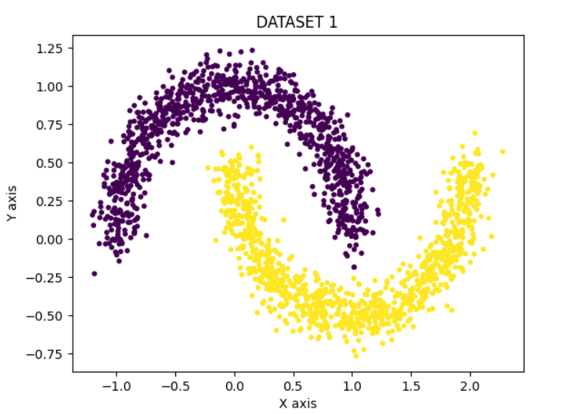 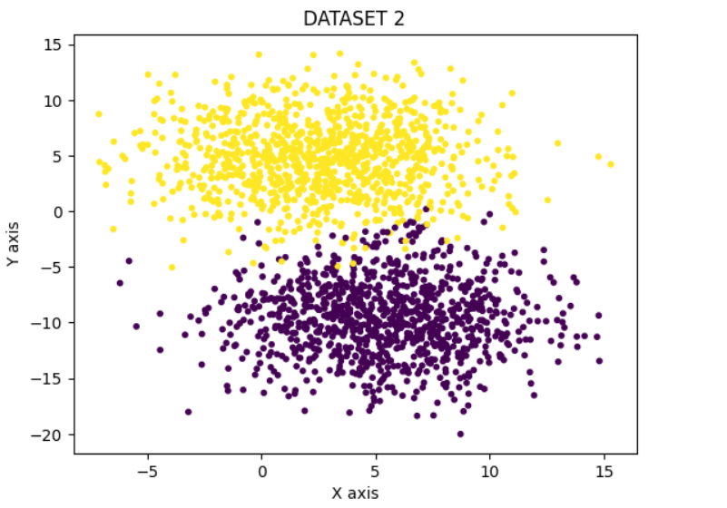

(Два датасети, розміром в 2000 екземплярів)

**AGNES**

**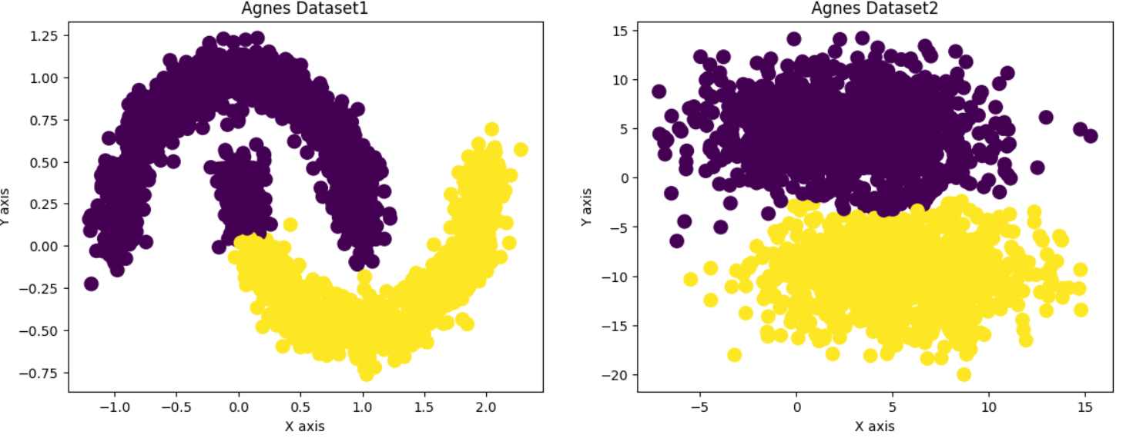  
Birch**

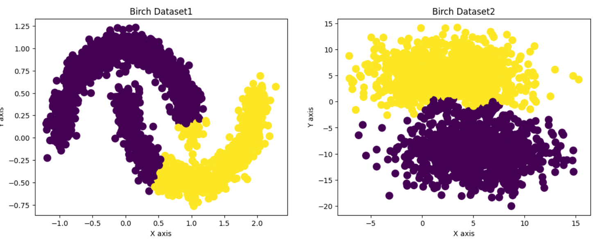

**DBSCAN**

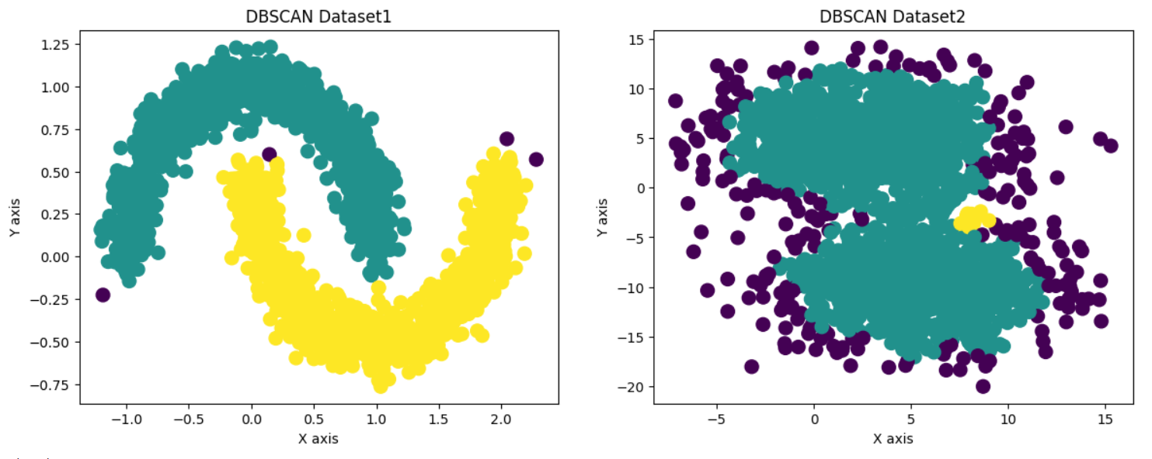

**Silhouette Coefficient**

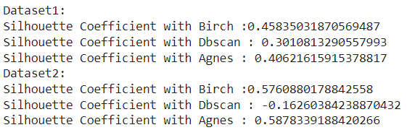

**ARI**

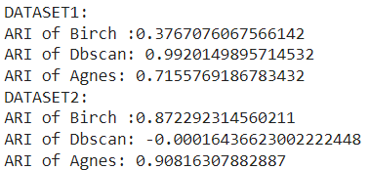

**NMI**

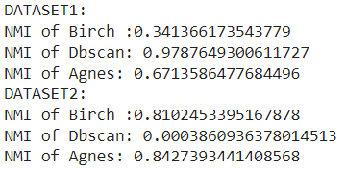

(Бачимо різницю в якості кластеризації для кожного датасету)

**ЗАВДАННЯ 4**

import pandas as pd

import seaborn as sns

import matplotlib.pyplot as plt

import numpy as np

from scipy import stats

mall_data = pd.read_csv('4.csv')

print(mall_data.head(5))

from sklearn.cluster import KMeans

X_numerics = mall_data[['Age', 'Annual Income (k$)', 'Spending Score (1-100)']]

KM_6_clusters = KMeans(n_clusters=6, init='k-means++').fit(X_numerics) # initialise and fit K-Means model

KM6_clustered = X_numerics.copy()

KM6_clustered.loc[:,'Cluster'] = KM_6_clusters.labels_ # append labels to points

KM6_clust_sizes = KM6_clustered.groupby('Cluster').size().to_frame()

KM6_clust_sizes.columns = ["KM_size"]

KM6_clust_sizes

from sklearn.cluster import AffinityPropagation

AF = AffinityPropagation(preference=-11800).fit(X_numerics)

AF_clustered = X_numerics.copy()

AF_clustered.loc[:,'Cluster'] = AF.labels_ # append labels to points

AF_clust_sizes = AF_clustered.groupby('Cluster').size().to_frame()

AF_clust_sizes.columns = ["AF_size"]

AF_clust_sizes

import plotly as py

import plotly.graph_objs as go

def tracer(db, n, name):

    '''

    This function returns trace object for Plotly

    '''

    return go.Scatter3d(

        x = db[db['Cluster']==n]['Age'],

        y = db[db['Cluster']==n]['Spending Score (1-100)'],

        z = db[db['Cluster']==n]['Annual Income (k$)'],

        mode = 'markers',

        name = name,

        marker = dict(

            size = 5

        )

     )

# Plotly interactive 3D plot

trace0 = tracer(KM6_clustered, 0, 'Cluster 0')

trace1 = tracer(KM6_clustered, 1, 'Cluster 1')

trace2 = tracer(KM6_clustered, 2, 'Cluster 2')

trace3 = tracer(KM6_clustered, 3, 'Cluster 3')

trace4 = tracer(KM6_clustered, 4, 'Cluster 4')

trace5 = tracer(KM6_clustered, 5, 'Cluster 5')

data = [trace0, trace1, trace2, trace3, trace4, trace5]

layout = go.Layout(

    title = 'Clusters by K-Means',

    scene = dict(

            xaxis = dict(title = 'Age'),

            yaxis = dict(title = 'Spending Score'),

            zaxis = dict(title = 'Annual Income')

        )

)

fig = go.Figure(data=data, layout=layout)

py.offline.iplot(fig)

# Plotly interactive 3D plot

trace0 = tracer(AF_clustered, 0, 'Cluster 0')

trace1 = tracer(AF_clustered, 1, 'Cluster 1')

trace2 = tracer(AF_clustered, 2, 'Cluster 2')

trace3 = tracer(AF_clustered, 3, 'Cluster 3')

trace4 = tracer(AF_clustered, 4, 'Cluster 4')

trace5 = tracer(AF_clustered, 5, 'Cluster 5')

data = [trace0, trace1, trace2, trace3, trace4, trace5]

layout = go.Layout(

    title = 'Clusters by Affinity Propagation',

    scene = dict(

            xaxis = dict(title = 'Age'),

            yaxis = dict(title = 'Spending Score'),

            zaxis = dict(title = 'Annual Income')

        )

)

fig = go.Figure(data=data, layout=layout)

py.offline.iplot(fig)

from sklearn.cluster import DBSCAN

DBS_clustering = DBSCAN(eps=12.5, min_samples=4).fit(X_numerics)

DBSCAN_clustered = X_numerics.copy()

DBSCAN_clustered.loc[:,'Cluster'] = DBS_clustering.labels_ # append labels to points

DBSCAN_clust_sizes = DBSCAN_clustered.groupby('Cluster').size().to_frame()

DBSCAN_clust_sizes.columns = ["DBSCAN_size"]

DBSCAN_clust_sizes

from sklearn.metrics import silhouette_score

sil_kmeans=silhouette_score(X_numerics,KM_6_clusters.labels_)

sil_af=silhouette_score(X_numerics,AF.labels_)

print("Silhouette Coefficient with K-Means :"+ str(sil_kmeans))

print("Silhouette Coefficient with Affinity Propagation : "+ str(sil_af))

from sklearn.metrics.cluster import adjusted_rand_score

ari_kmeans=adjusted_rand_score(DBSCAN_clustered.loc[:,'Cluster'],KM6_clustered.loc[:,'Cluster'])

ari_af=adjusted_rand_score(DBSCAN_clustered.loc[:,'Cluster'],AF_clustered.loc[:,'Cluster'])

print("ARI of K-Means :"+ str(ari_kmeans))

print("ARI of Affinity Propagation: "+ str(ari_af))

from sklearn.metrics.cluster import normalized_mutual_info_score

nmi_kmeans=normalized_mutual_info_score(DBSCAN_clustered.loc[:,'Cluster'],KM6_clustered.loc[:,'Cluster'])

nmi_af=normalized_mutual_info_score(DBSCAN_clustered.loc[:,'Cluster'],AF_clustered.loc[:,'Cluster'])

print("NMI of K-Means :"+ str(nmi_kmeans))

print("NMI of Affinity Propagation: "+ str(nmi_af))

**K-means**

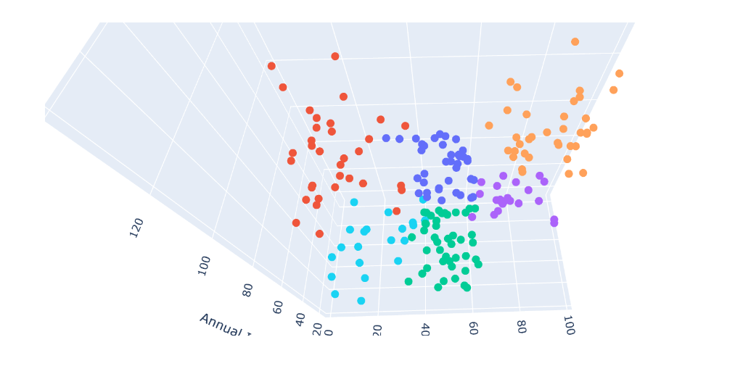

**Affinity Propagation**

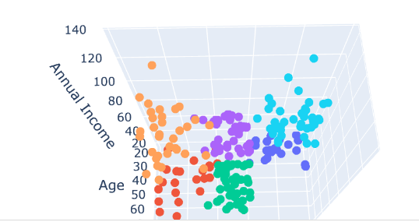

**Metrics:  
